MyConfig® Training Quiz

Name: __________________________________ Score: / 24

Please complete the following questions. Submit your quiz to stefanie@myomo.com in order to receive your score and answer key.

- Which of the following statements about the Threshold line is true?
  - The Threshold is the line the EMG signal needs to cross in order to trigger the motor to move the user’s arm.
  - The Threshold should be high enough to ensure a high tone user can relax quickly below it to trigger elbow extension (in bicep mode).
  - There are 2 Threshold lines in Dual mode.
  - The Threshold should never be set above 5.
  - a, b and c

- What is the purpose of MyConfig?
  - To customize the sensitivity of the MyoPro for the user and thereby provide successful elbow and/or hand movement.
  - To see the real-time EMG activity of the user.
  - To assist with troubleshooting.
  - All of the above

- What is the difference between Gain and Boost?
  - Gain makes the MyoPro move faster.
  - Boost allows the user to pick up heavier items.
  - Gain is the EMG amplification at the hardware level (sensor), Boost is the EMG amplification at the software level.

- While using Tricep mode, the message “Triceps off scale” appears at the top of the screen. Why is this happening and what is the solution?

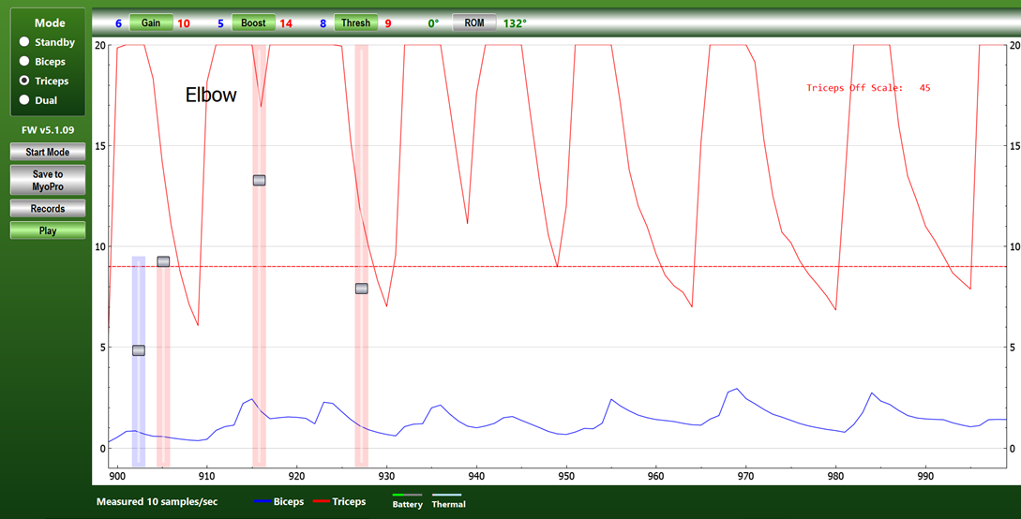

  - The tricep sensor is in the wrong place, relocate the sensor.
  - The tricep EMG has been overamplified, lower the Gain and/or Boost.
  - The user has become too strong for the MyoPro, discontinue use.
  - The tricep EMG has been overamplified, raise the Threshold line.

- If you are not seeing a responsive EMG signal on MyConfig, what could be the reason?
  - The sensors are in a poor position.
  - The candidate does not have adequate EMG to power a MyoPro.
  - The sensors are not tight enough against the skin.
  - The sensors may be defective – test them on your arm to find out.
  - All of the above.

- When a candidate tries to contract his/her biceps…
  - The blue line in MyConfig should rise.
  - The red line in MyConfig should rise.
  - The hand should close.
  - The elbow should extend.

- When in Biceps mode, in order for the MyoPro to extend, the user must?
  - Co-contract biceps and triceps.
  - Relax biceps.
  - Contract biceps.
  - Contract triceps.
  - None of the above.

- When making adjustments to the MyoPro or assessing sensor placement, what is the best mode to be in?
  - Standby mode.
  - Biceps mode.
  - Open mode.
  - Dual mode.
  - Close mode.

- What is a hallmark of a high tone EMG signal?
  - Smooth curve
  - Erratic and jagged
  - Difficult to relax
  - b and c

- Botox can affect the EMG signal: TRUE or FALSE

- A MyoPro user is unable to make their arm move, despite attempting a muscle contraction. What could explain why isn’t the MyoPro responding?
  - The Threshold is too high and the user is not generating a strong enough EMG signal to cross it.
  - The MyoPro is in standby mode.
  - The sensors are not in the correct location on the arm.
  - a, b and c

- What is the word to describe rapid, unintended movement of the MyoPro?
  - Stagnation
  - Obfuscation
  - Oscillation
  - Obliteration

- What can be done to help a user who is fatiguing to work a little longer?
  - Raise the Threshold line.
  - Lower Gain below 4.
  - Put the MyoPro in standby mode.
  - Raise Gain or Boost.

- High tone users may benefit from:
  - A raised Threshold line.
  - A Threshold line set below 5.
  - Boost set above 10.

- A MyoPro user presents with MMT scores of 1/5 in their wrist extensors and 2+/5 in their wrist flexors. Which settings for Open and Close mode are most appropriate?
  - Open mode: Gain = 10, Boost = 4, Threshold = 14;
Close mode: Gain = 10, Boost = 20, Threshold = 2
  - Open mode: Gain = 10, Boost = 14, Threshold = 5
Close mode: Gain = 10, Boost = 0, Threshold = 5
  - Open mode: Gain = 10, Boost = 14, Threshold = 5
Close mode: Gain = 9, Boost = 7, Threshold = 6

- Incremental movements through the user’s ROM is possible in dual mode: TRUE or FALSE
  - This is due to the presence of 2 threshold lines: TRUE or FALSE

- While working with a MyoPro user, the clinician sees this on MyConfig:

Answer the following questions about this image:
  - What mode is currently being used? _____________
  - What is the word used to describe this pattern of EMG activity? ___________________
  - What is the elbow ROM currently set to? ______ extension to _______ flexion
  - What could be some possible causes of this pattern of EMG activity? Please list 3

ii.
iii.

- When trying to activate their bicep, a MyoPro user is observed to hold their breath, abduct their shoulder and extend their trunk. What can be done to make it easier for them to move their arm and rely less on these compensatory strategies?
  - Tell the user to focus on grasp and release instead.
  - Encourage the user to co-contract bicep and tricep.
  - Raise Gain and/or Boost.
  - Raise the Threshold line.

- The fit of a MyoPro on the user’s arm can impact both the quality of movement and what the clinician can expect to see on MyConfig. If a MyoPro has been donned incorrectly, resulting in a loose upper arm cuff and misalignment at the elbow and wrist joints, what might the clinician see on MyConfig?
  - Erratic EMG activity resulting in oscillation and unintended movement in the MyoPro.
  - A smooth EMG curve.
  - A low amplitude EMG signal.
  - A high amplitude EMG signal.

- Making regular adjustments to Gain/Boost/Threshold during a therapy session will override the previously programmed settings? TRUE or FALSE

- What effect might perspiration have on the EMG activity?
  - No effect.
  - EMG signal may flatline and be unresponsive.
  - Only the EMG activity from the flexor groups will be visible.

- Can the user’s position and posture (e.g. standing vs sitting) effect the quality and amplitude of their EMG signal? YES or NO

- Can a MyoPro be used without connecting to MyConfig? YES or NO

- When programming settings for a brand new MyoPro user, what should be the clinician’s ultimate goal?
  - To make sure the user has to work as hard as possible to move their arm.
  - To make sure the user can move their elbow (and hand) as smoothly as possible, with moderate effort and minimal compensatory movements.
  - To make sure the MyoPro only responds to the user’s extensor signal(s).

